

Penitration testing

& sEcuring cloud

network

**R0HIT GUPTA**

**SECURITY**

**SNORT**



Snort is a free open source network intrusion detection system (IDS) and intrusion prevention system (IPS) created in 1998 by Martin Roesch, founder and former CTO of Sourcefire. Snort is now developed by Cisco, which purchased Sourcefire in 2013, at which Roesch is a chief security architect.

**INSTALLING SNORT REPOSITORIES AND PACKAGES**

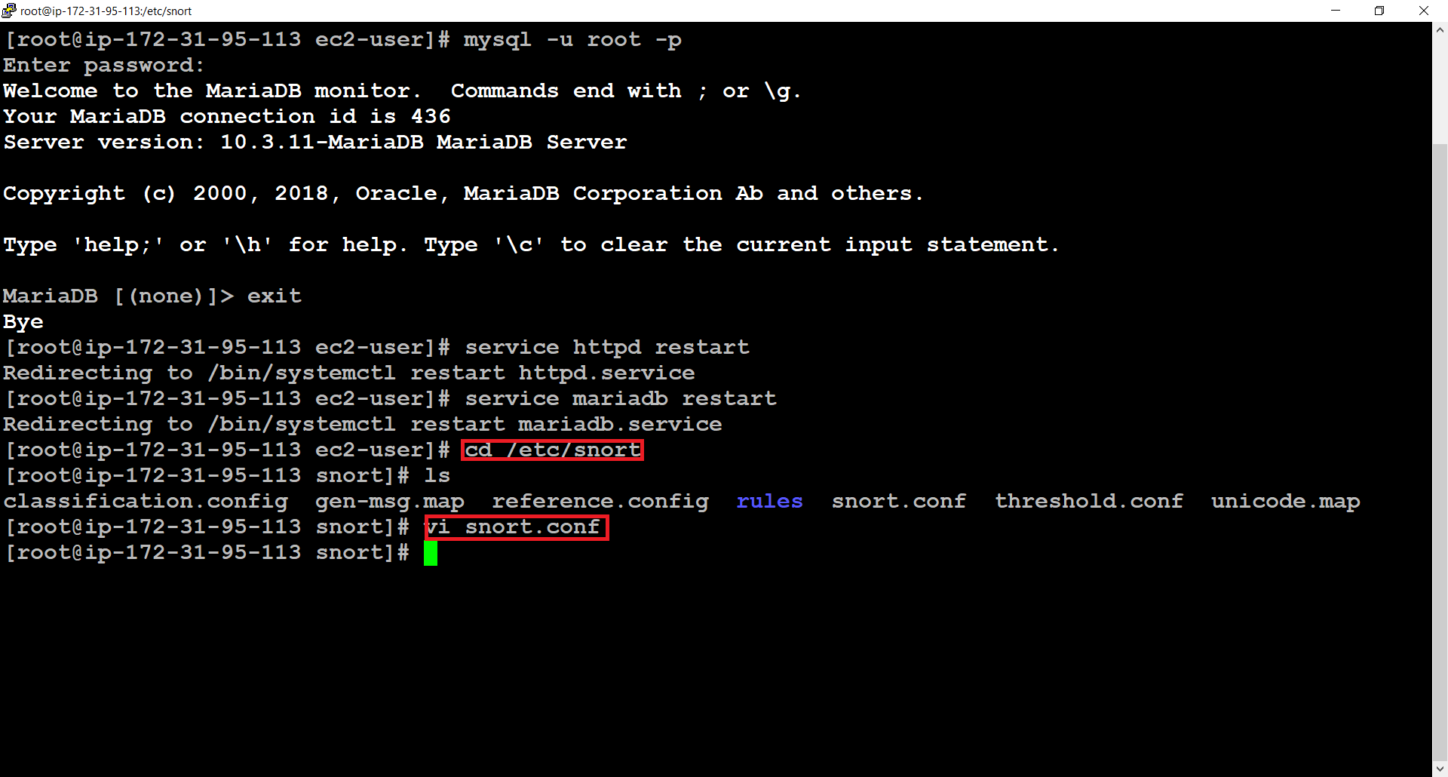

**CONFIGURING SNORT**

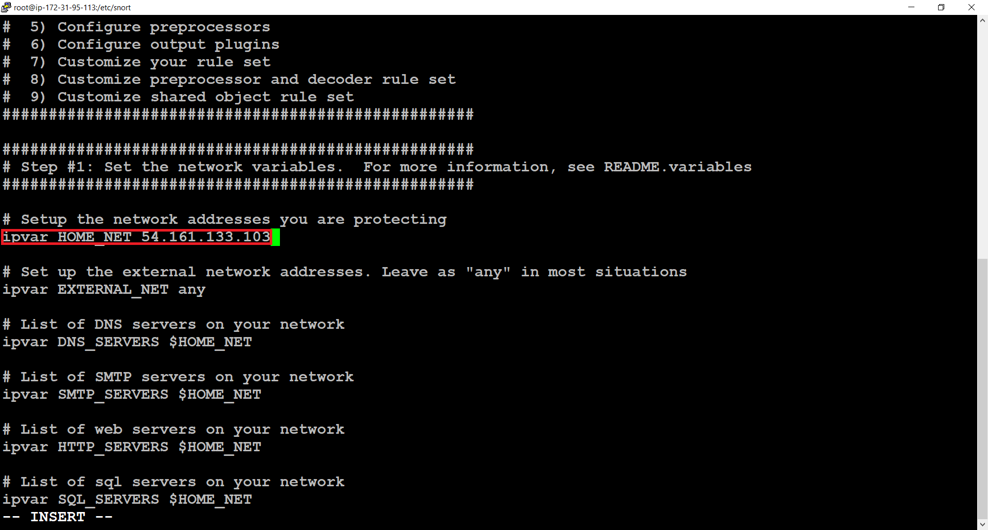

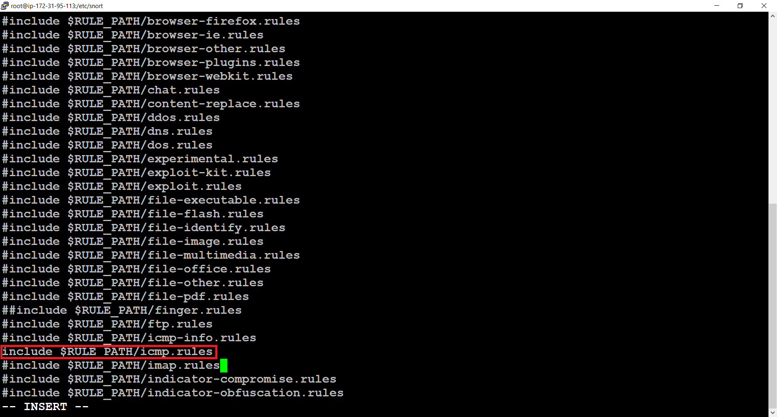

**CONFIGURING THE RULES FOR ICMP AND HTTP**

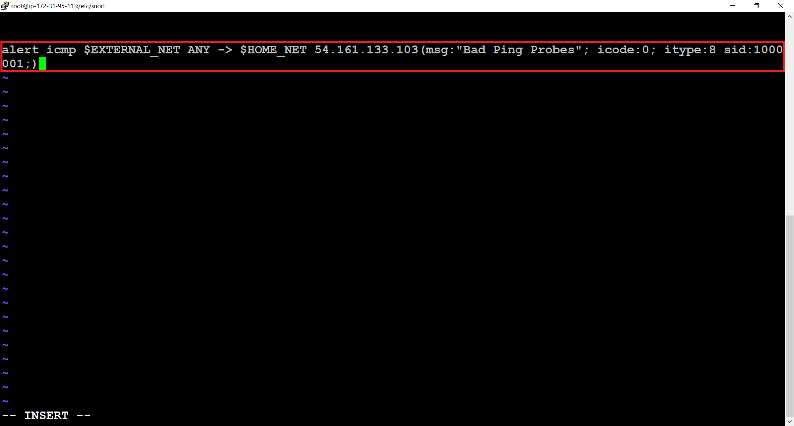

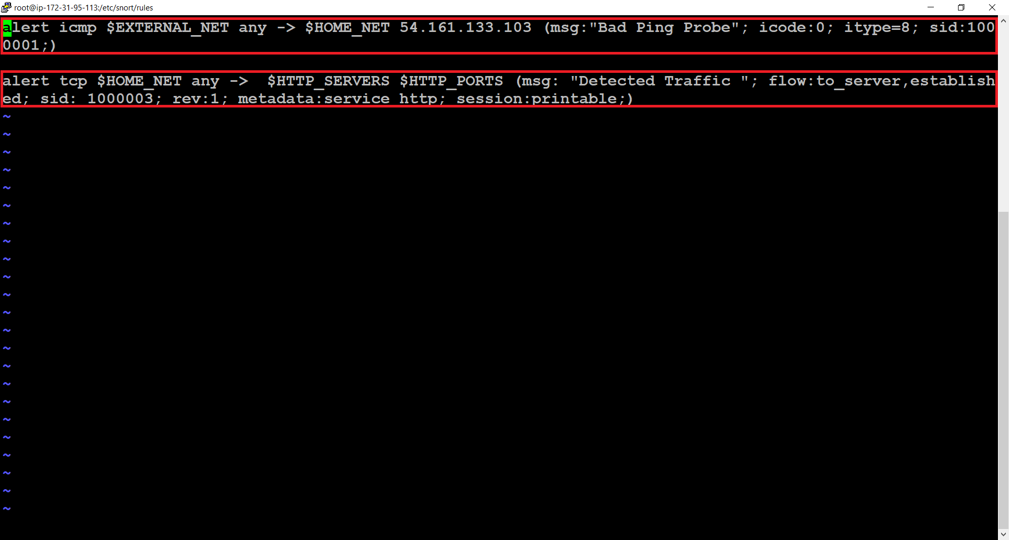

**INSTALLING AND CONFIGURING HONEYPOT**

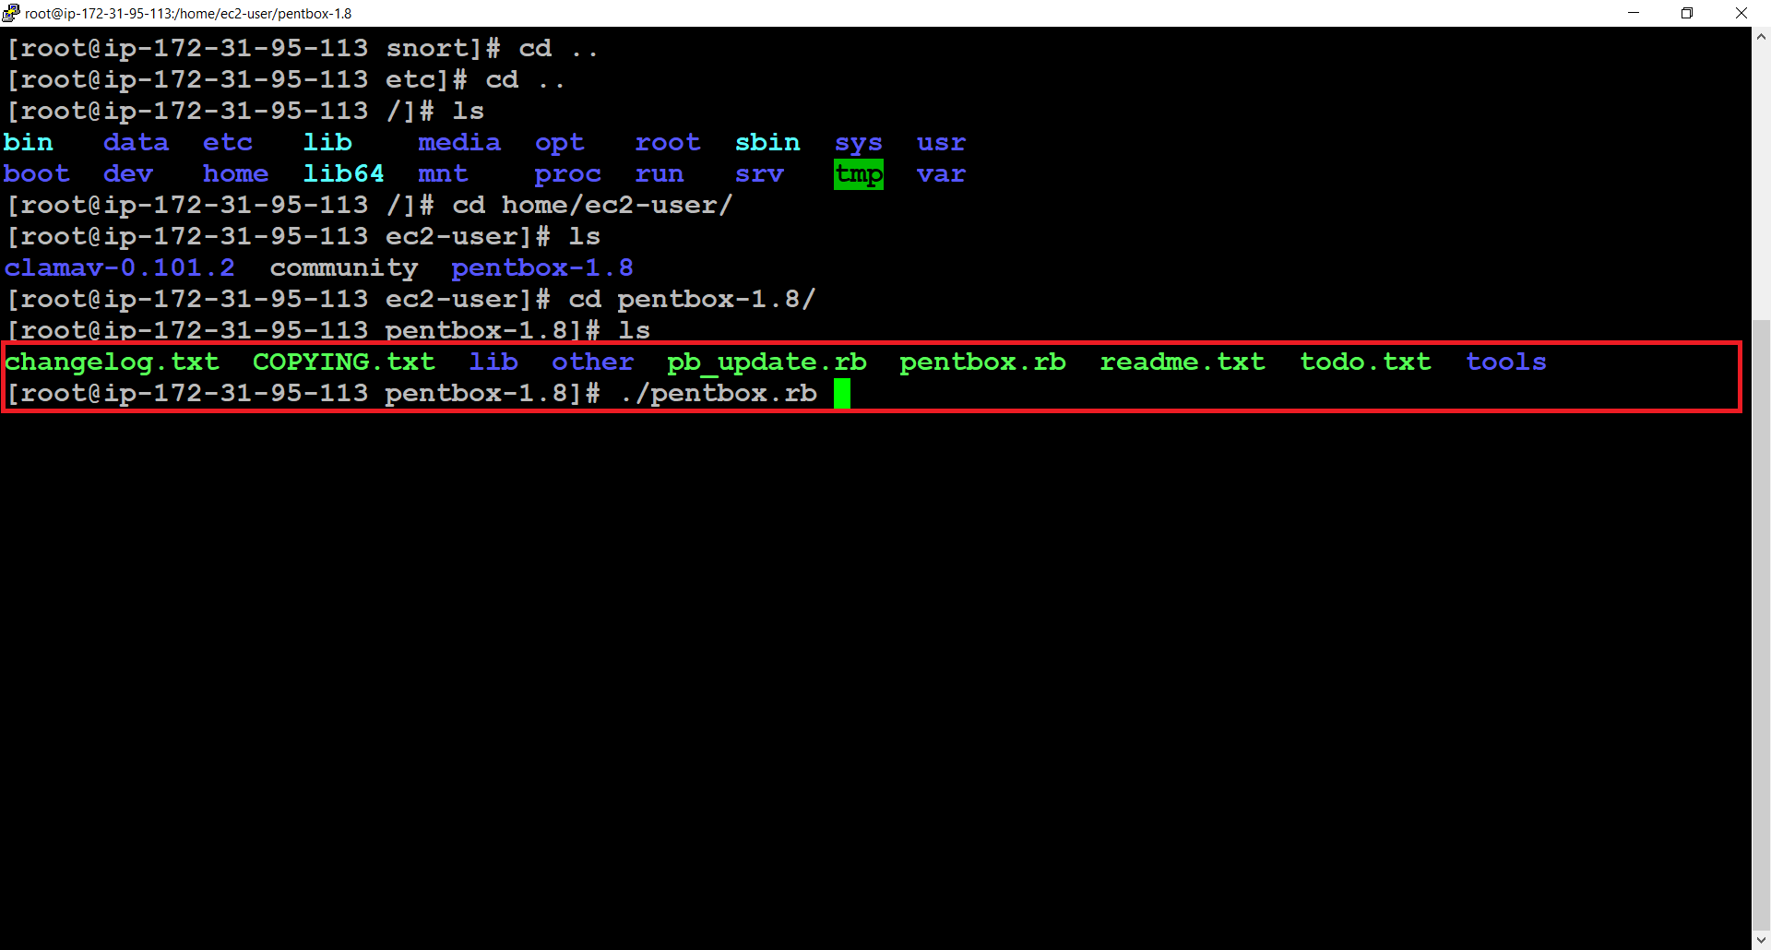

>>PentBox

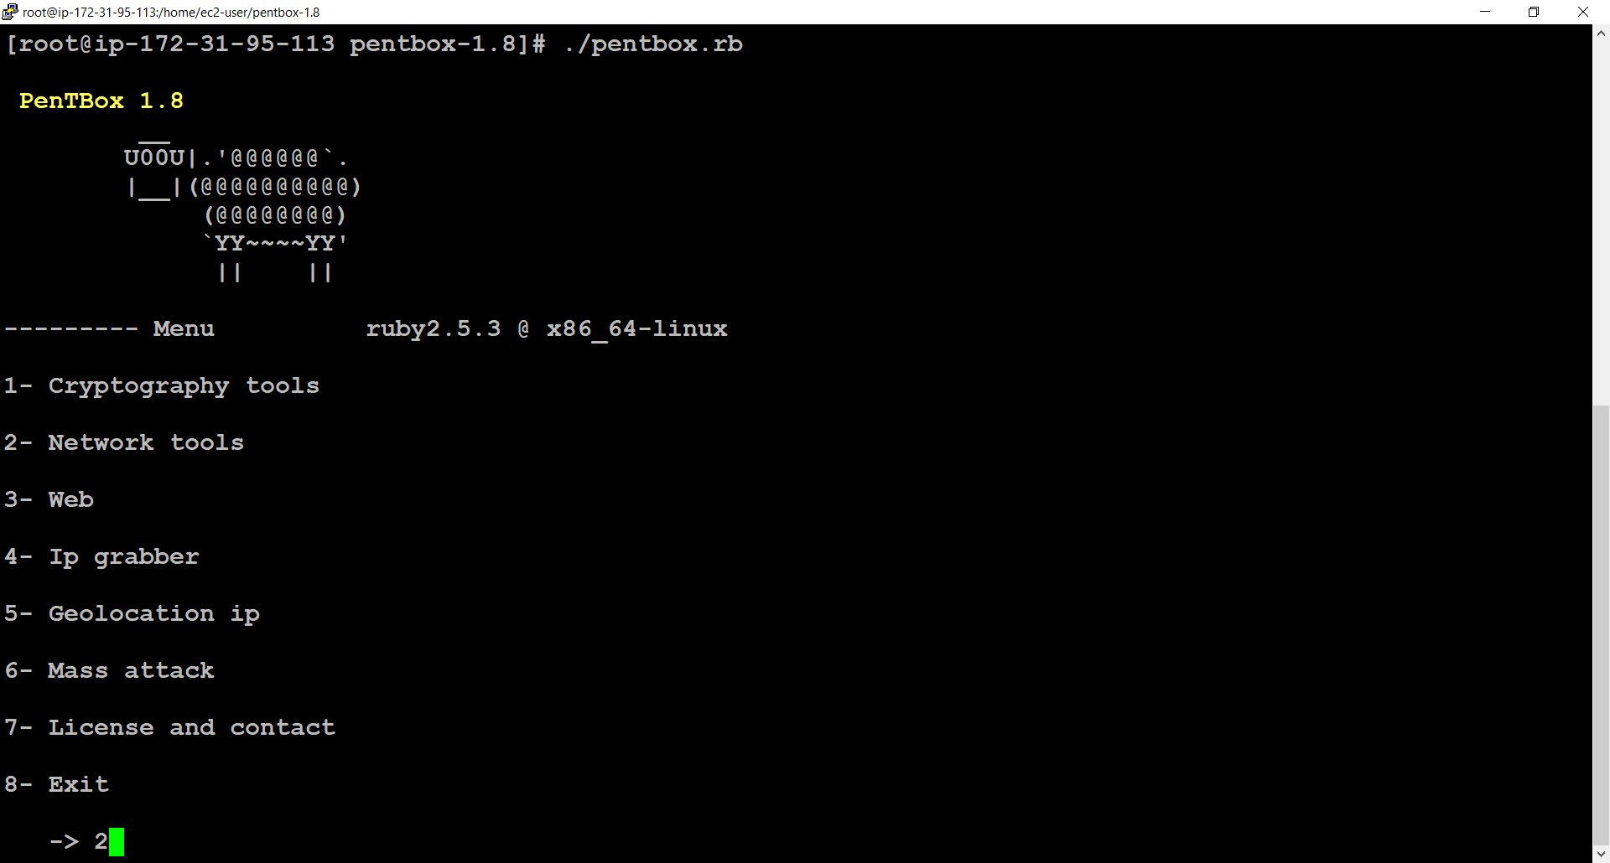

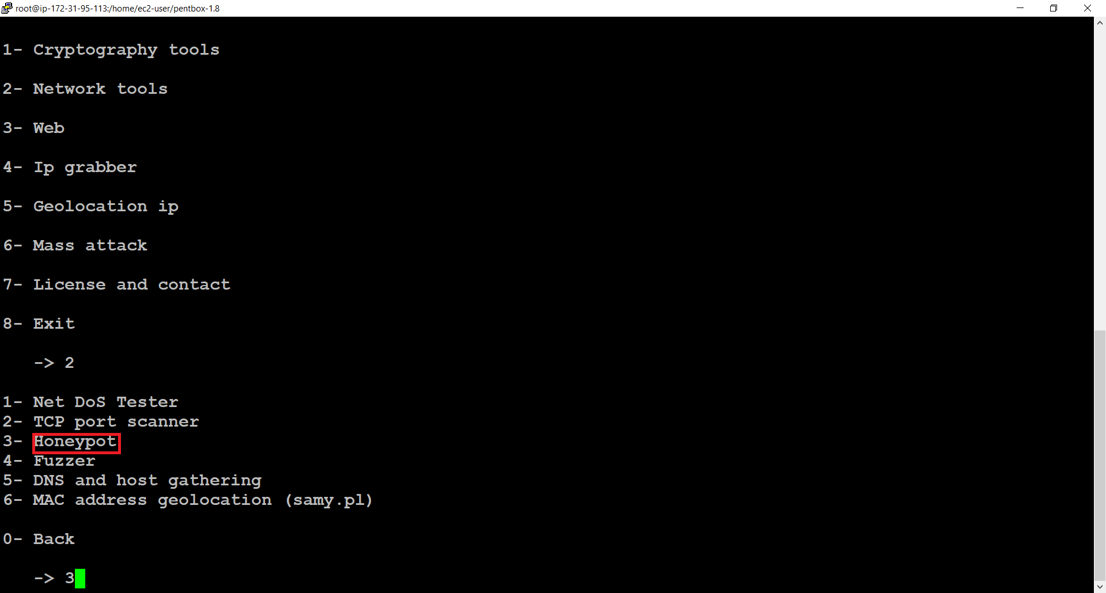

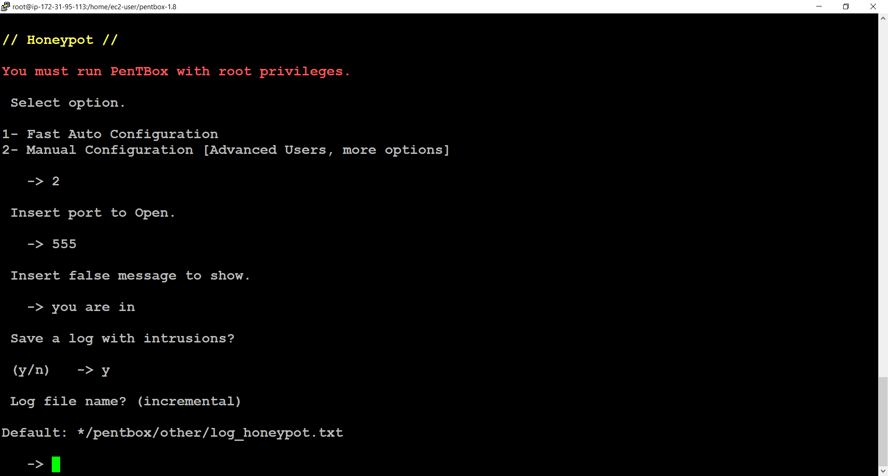

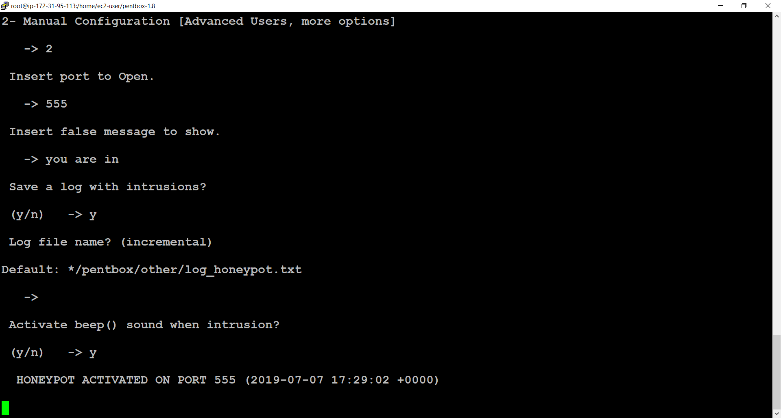

>>After implementing honeypot

